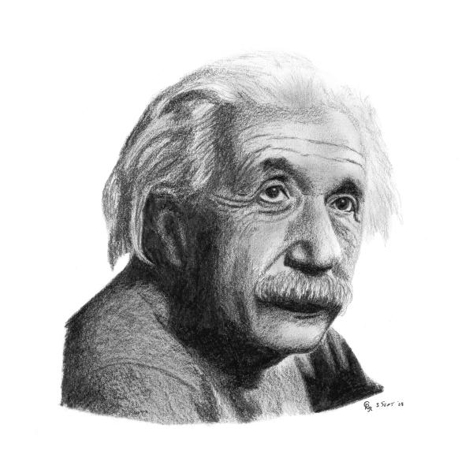 | International Interdisciplinary  Technical Conference of Young Scientists  Opole, Poland

The Very Interesting Document with the Very Long Title

Tom Nielsen, Very Modern University of Technology

larastew@vvmut.mail.address.com

Abstract: The extended abstract should be written in: Arial, bold, 8pt size. The abstract should give the short information about the article and its content should not be less than 120 words.
Keywords – document, very interesting method, VVM, please use the InterTech_KeyWords style
- Introduction
The article should be written in two columns (7.5 cm width, 1cm distance between the columns). The margins should be as follows: left 2.5 cm, right 2.5 cm. bottom 2.5cm and top 2.5cm, except the top margin on the first page, which should be at least 5 cm. The whole article should not exceed 5 pages. The document will be accepted in pdf format only (the document cannot be protected) with the page layout set to A4 (210×297mm). Please, do not number the pages!
To ensure that the document layout is correct with the template, the organizers suggest to use the styles provided in the template. You can find them in the following menu: “Format ⇨ Styles and Formatting…”. All of the styles begin with the phrase “InterTech-“ i.e. the abstract part uses the style “InterTech_Abstract”.
The title style is 20pt high Arial bold, one–column centered text (use InterTech_title style).
The author part should be written using 11pt Arial normal, centered (use InterTech_Authors style). This part should contain the names of all the authors, their affiliations and e-mail address.
The abstract part should be written using 8pt Arial bold, justified. The distance between the author information and the abstract should be 9pt.
The Keywords part should be written using 8pt Arial bold italic, justified. The distances to the abstract part and the subtitle part should be 6pt and 18pt respectively. Please use the InterTech_KeyWords style.
All the subtitles should be written with the 11pt Arial normal, justified. The distance between the subtitle and the text should be 9pt.
The text in all of the sections should be written using the InterTech_Text style: 11pt Arial normal, justified.
- Pictures and figures
The pictures, graphs, figures etc. should be centered (please use the InterTech_Fig style). Please provide the pictures of good quality, as the document will be printed in grayscale. The included pictures should be “aligned with the text” (Format ⇨ Pictures, click on the Layout tab and then choose the “align with the text” option). See the example below.
The legend under the pictures shall use the InterTech_Legends style. The legend should be written using 10pt Arial, centered, bold. The distance between the legend and the text or the next figure should be 10pt. The pictures should be numerated uniform on the trot in the whole article (without the marking of the section number).
Figure 1. This is the picture
- The Equations
All the equations should be written using the MS Equation Editor or Math Type (InsertðObjectðMS Equation Editor or MathType). The size of the basic equation element should match the size of the text, i.e. 11pt. The distance between the equation and the text (or other objects) should be 6pt. The equations should be numerated on the trot and the equation numbers should be placed in the brackets on the right side of the column. Please, use the InterTech_Equations style.
(1)
- Lists
The lists should be prepared as follows: you can use the ordered (InterTech_List_Num style) and unordered (InterTech_List_Bullet style) lists. The indentation before the number or the bullet should be 0.3 cm. The distance between the second line and the left border of the column should be 0.7cm. See the examples below:
- This is the first line of the list; this is the second line of the list
- This is the third line of the list
- This is the first line of the bullet list, this is the second line of the bullet list
- This is the third line of the bullet list.
- Tables
Tables should be centered and the text within the cells should be Arial 10pt, centered (and bold if needed). Use the InterTech_Table style. The description of the table should be placed above them, centered, as in the example:
Table 1. The very first table
Lp | Value1 | Value2 | Value3 | Value4
1 | 1 | 2 | 3 | 4

For table legend use the InterTech_Leg_Table style. The tables should be numerated in the same way as the figures. The distance between the legend and the table should be 6pt and the table and the text - 11pt.
- Conclusions
The conclusion section should not be a repetition of the abstract part. It should present the main conclusions of the presented article and inform about the further direction of investigation.
The total size of the document in pdf format should not exceed 2 MB.
- References
For references please use the square brackets in the text (like [1]). In references part please use the InterTech_Ref style. The references should be written in 8pt Arial, adjusted. See the example below:

- S. Seri, K. Smallhand, “The very effective method of the computing using new applications”, Very Big Organization, vol. 4, no 2, pp. 1234-1238
- K.Bighad, “The computer simulations”, TheCityName, ThePublisherName 2006

